**Monitoring Task**

**Task Description:**

Install Prometheus and Grafana on a Linux EC2 machine, connect Prometheus to Grafana, and create a dashboard to view metrics.

**Step 1: Launch EC2 & Configure Security**

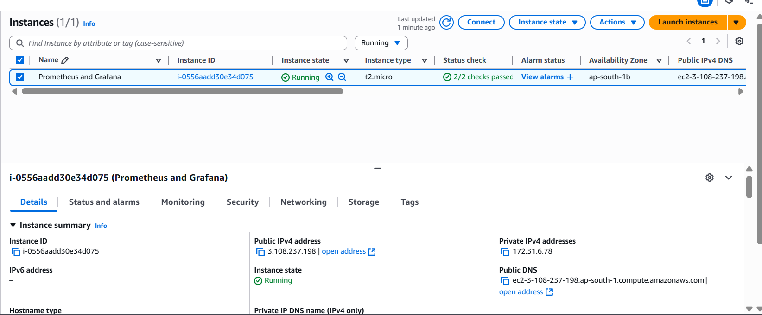

**sudo apt update && sudo apt upgrade -y**

**sudo apt install wget curl tar -y**

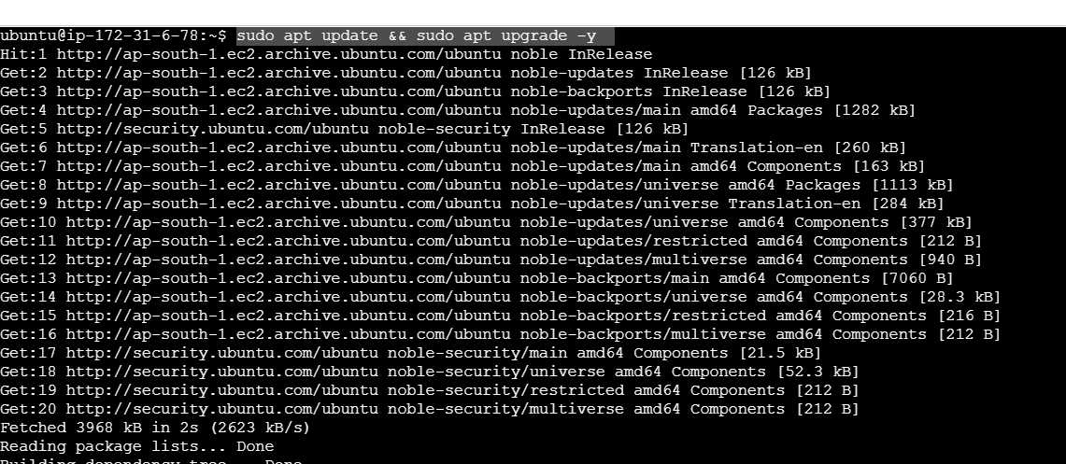

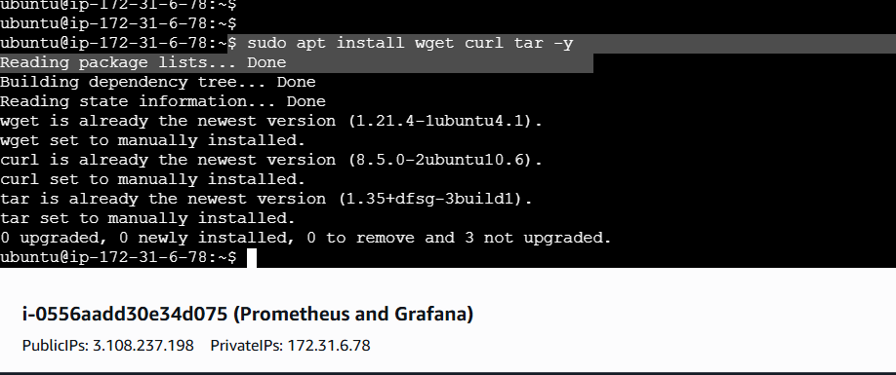

**Step 2 : Install Prometheus and configure**

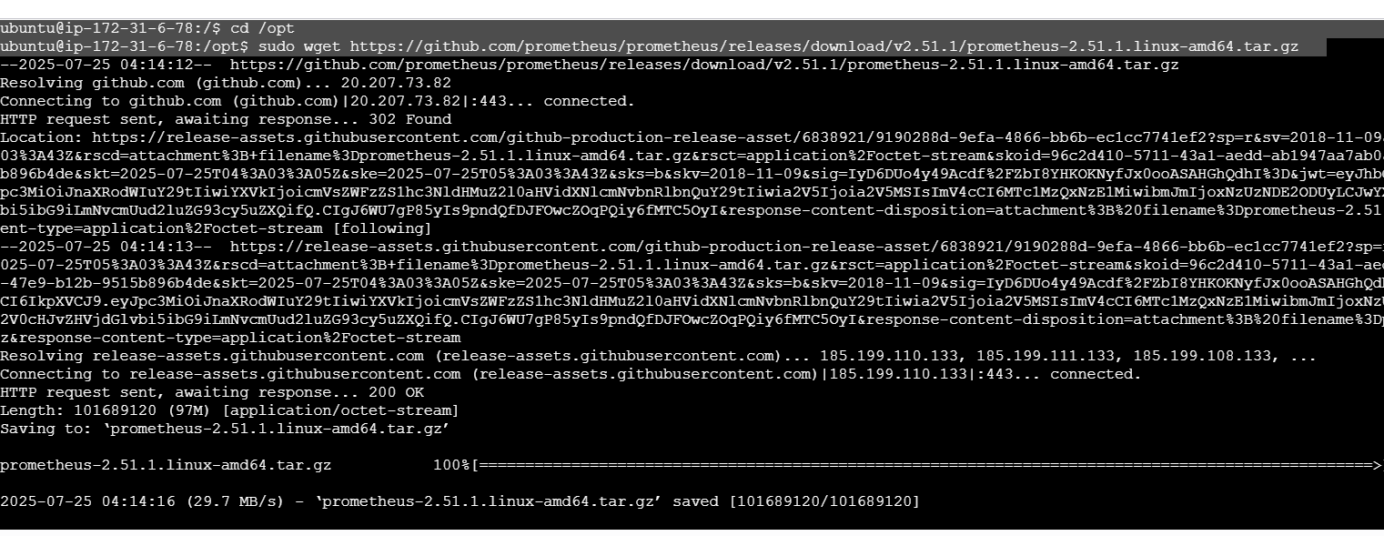

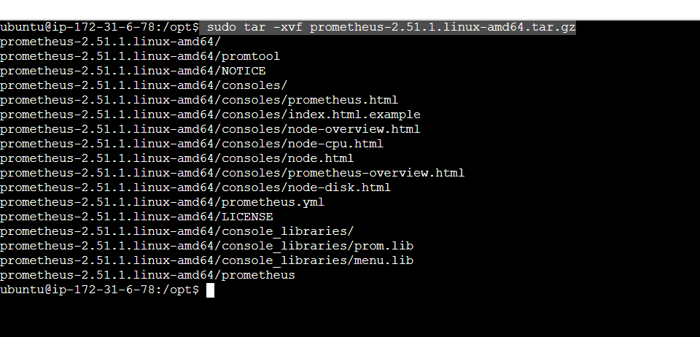

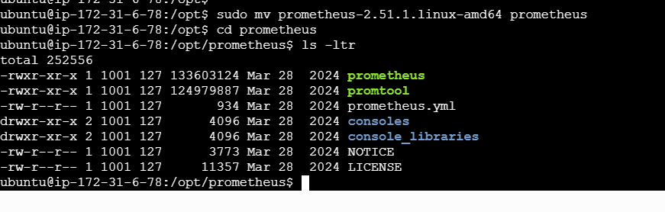

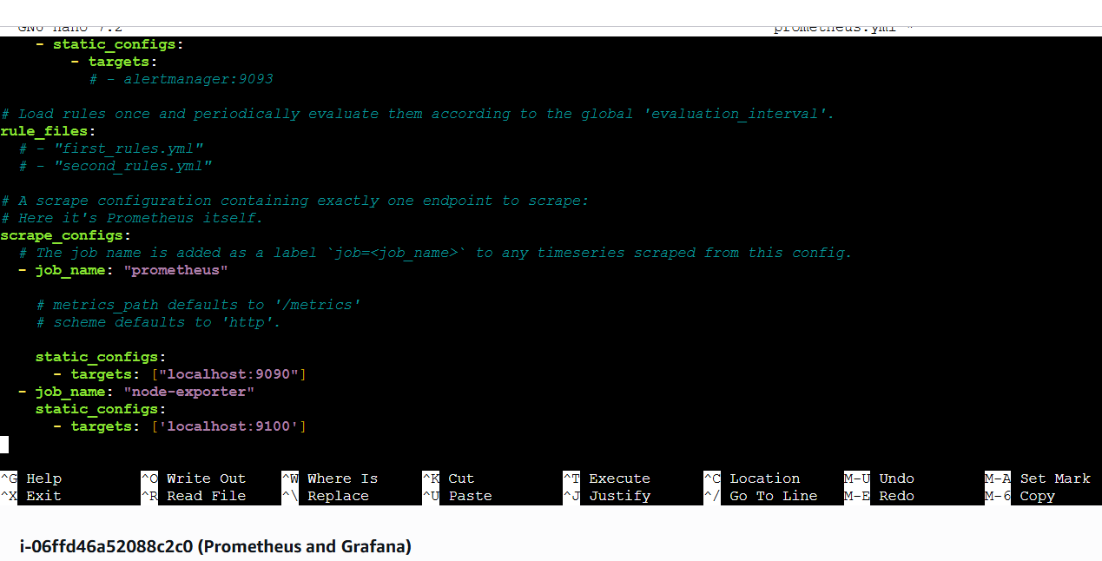

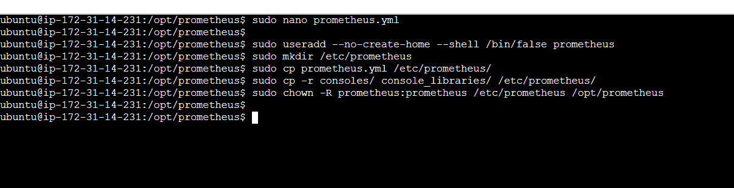

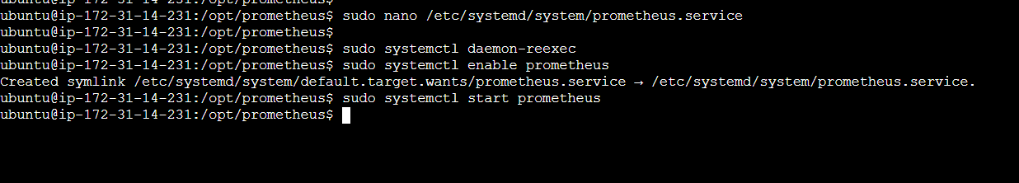

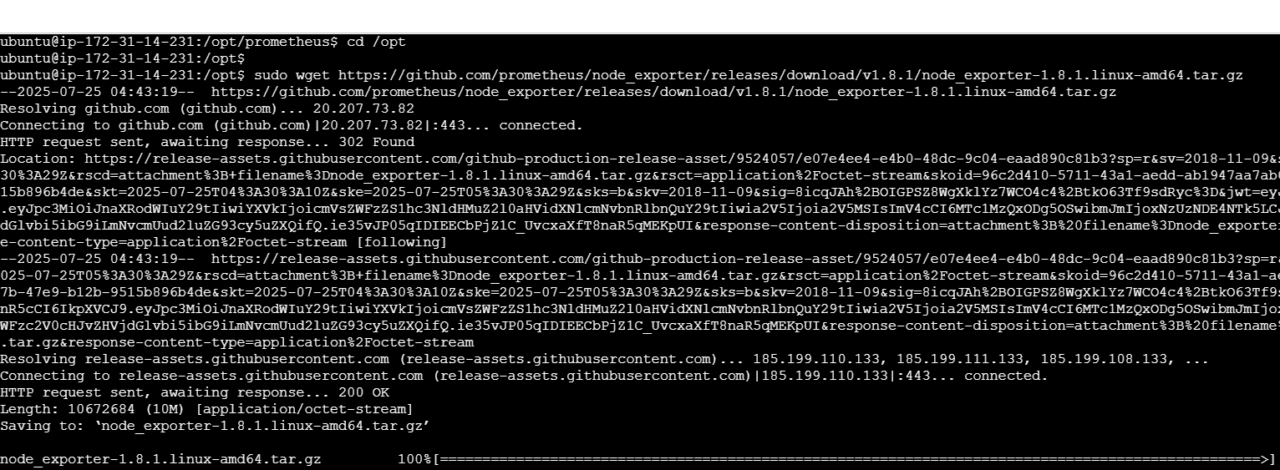

**Step 3: Install Node Exporter**

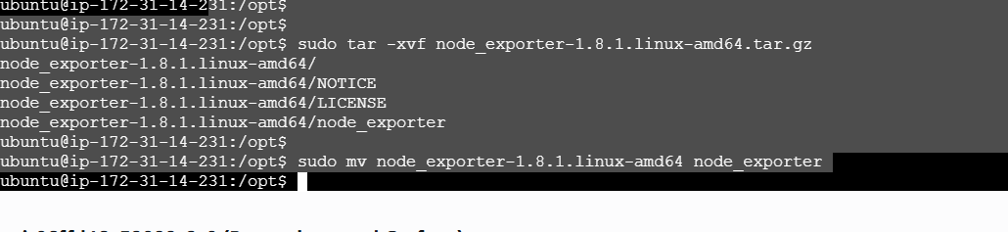

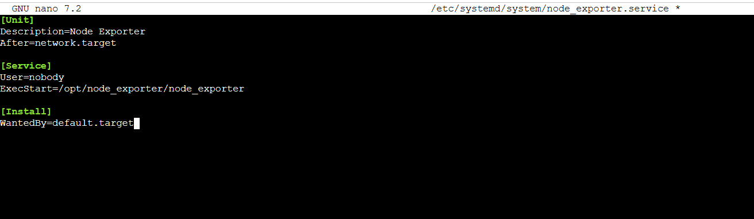

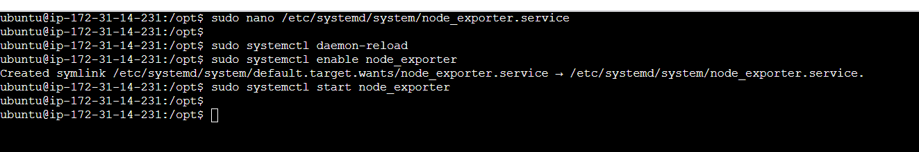

**http:// http://13.204.81.17:9090— Prometheus and Node Exporter up.**

**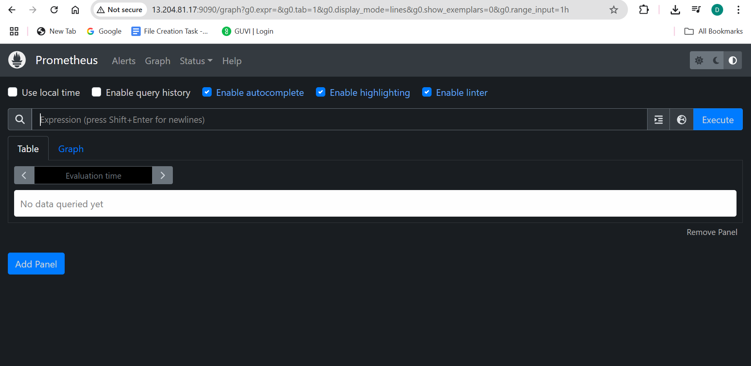  
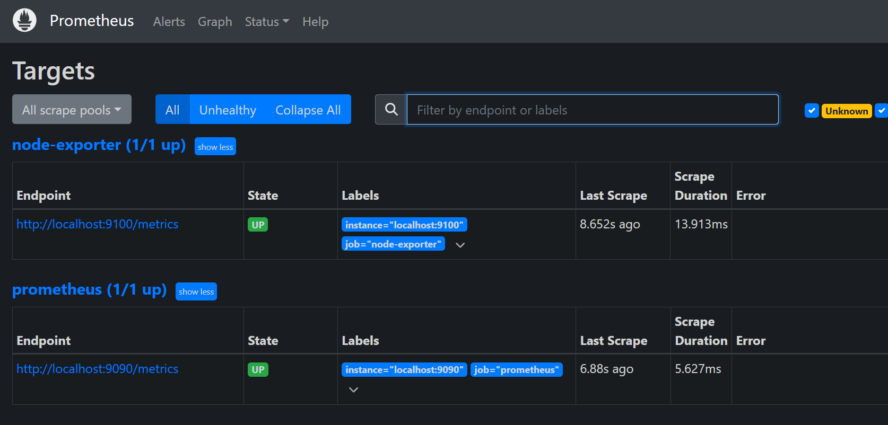**

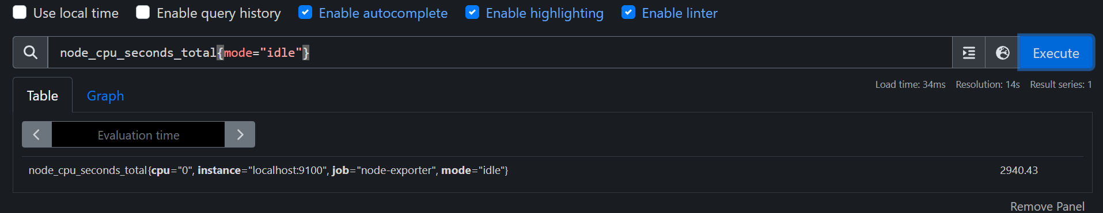

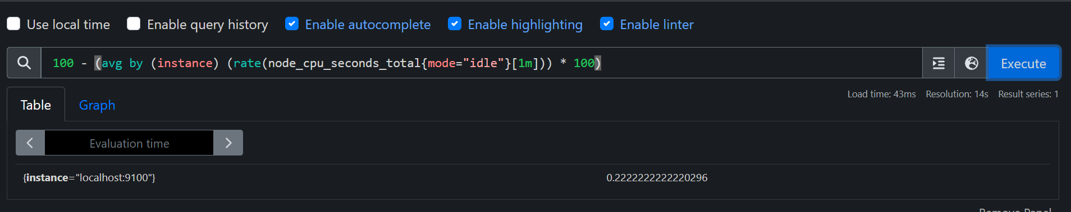

**Step 5: Install Grafana and configure to dashboard**

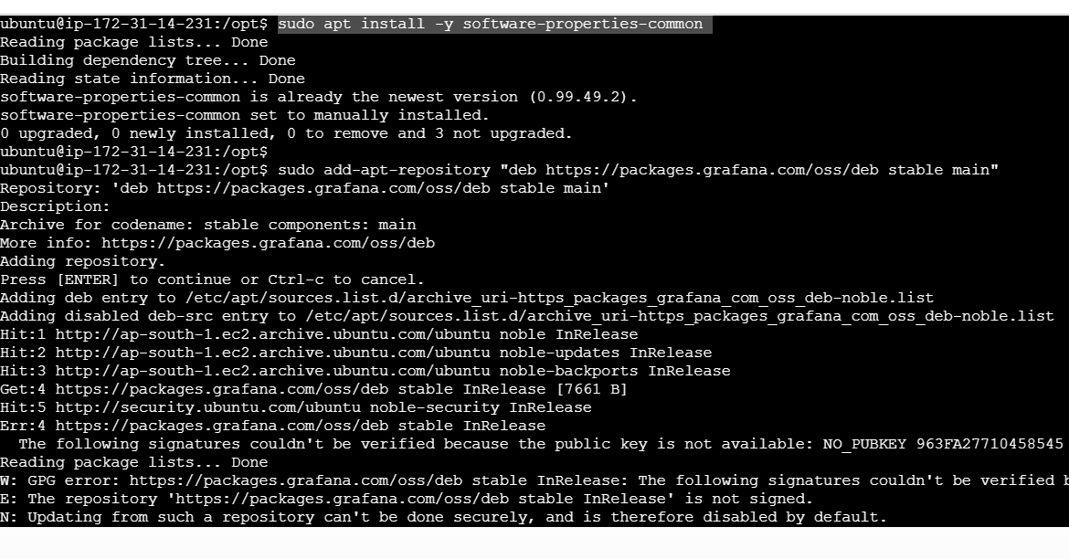

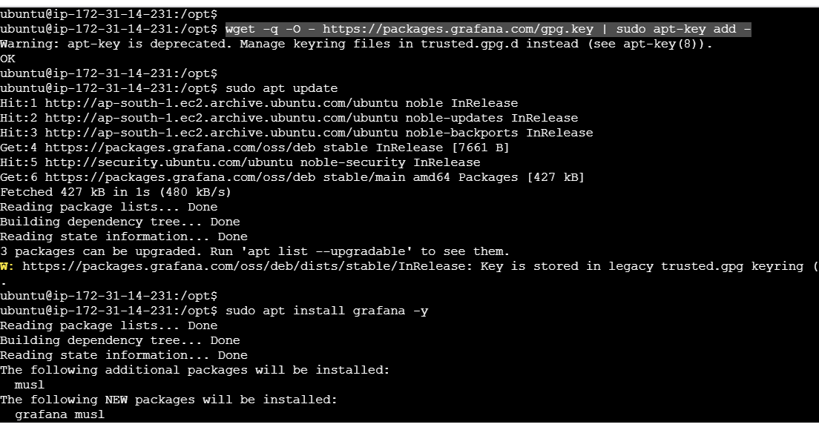

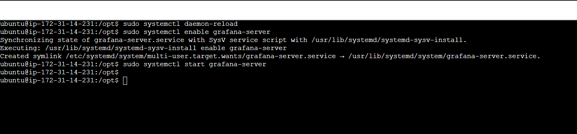

**Step 6: Connect Prometheus to Grafana  
